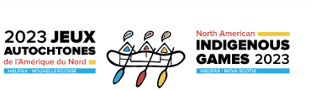

SPONSORSHIP PACKAGE

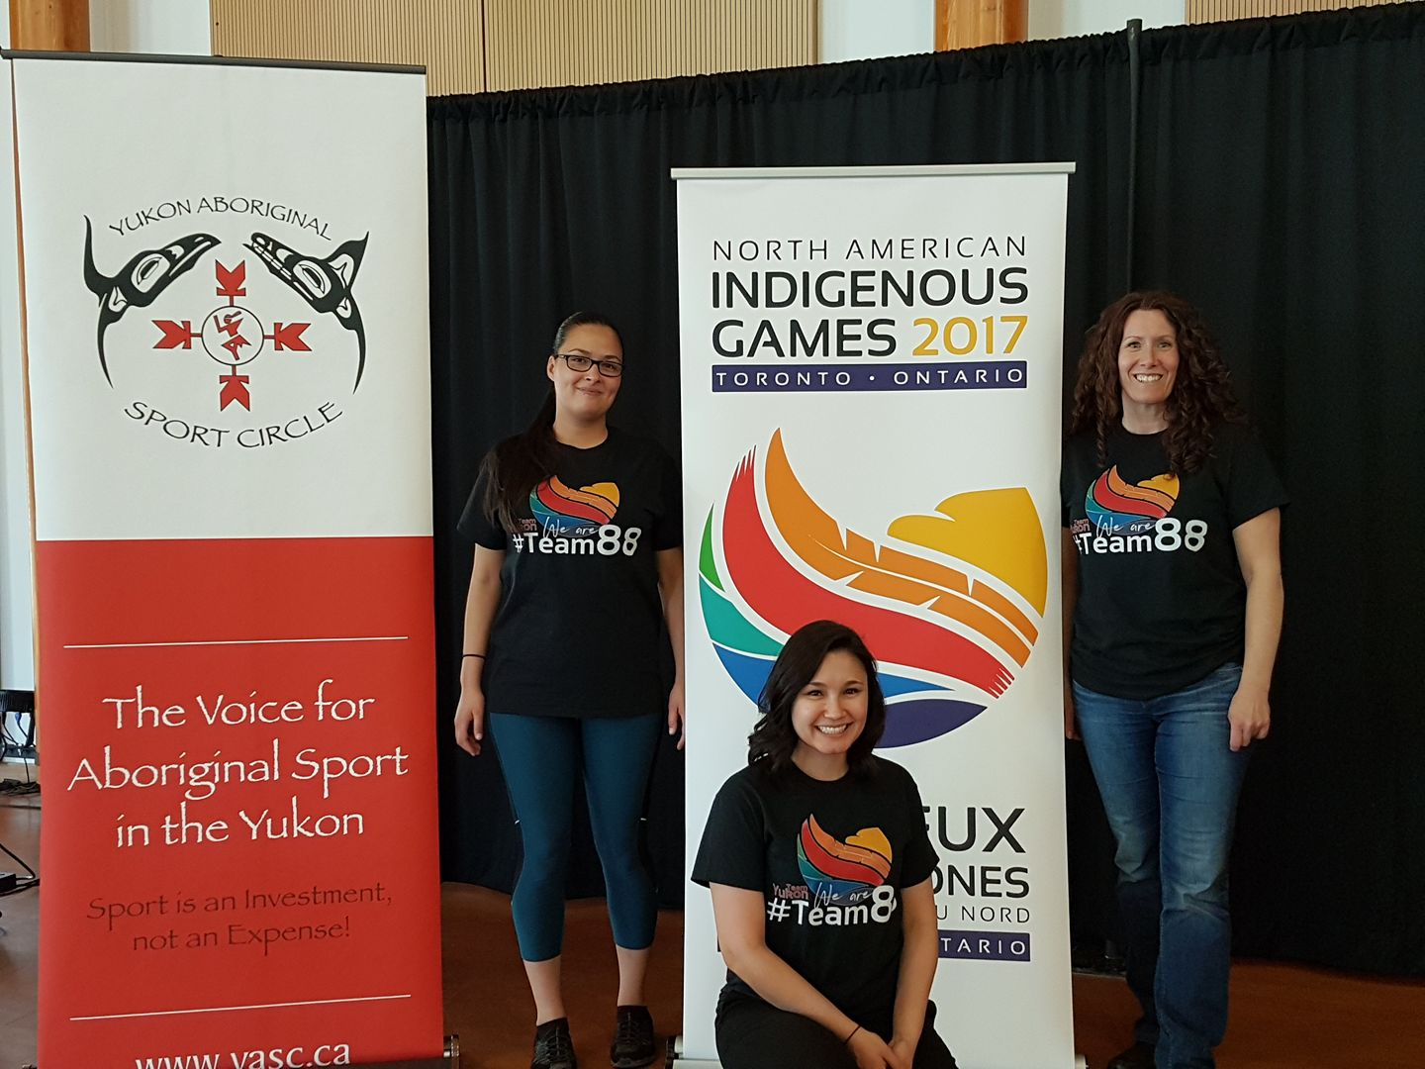

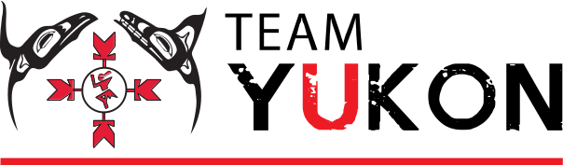

Yukon Businesses, do you…

- Wish to support First Nations Culture?
- Desire to give back to your community?
- Want to promote health and leadership in First Nation Youth?
- Need a tax break?
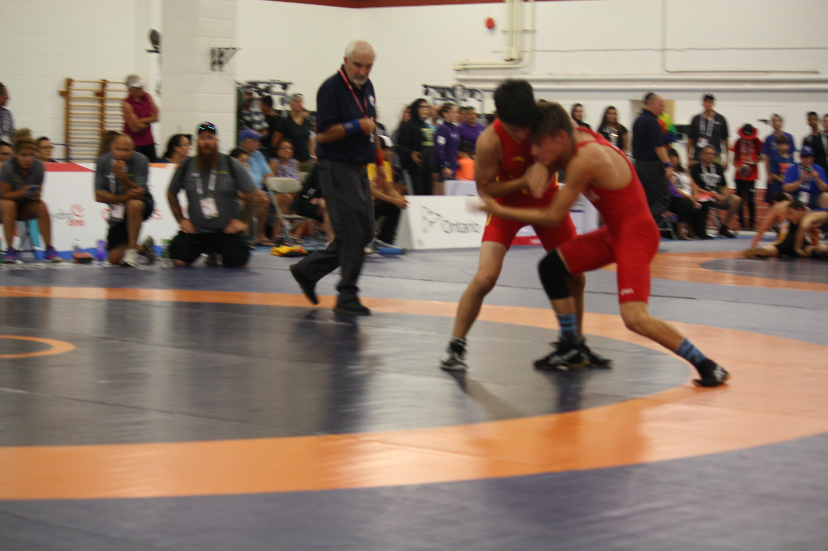

Team Yukon and Yukon Aboriginal Sport Circle is reaching out to local businesses. We are seeking financial support for the First Nation Youth of the Yukon wanting to participate in the North American Indigenous Games 2023

North American Indigenous Games 2023
The 2023 NAIG games will take place between July 15-23, 2023 in Kjipuktuk (Halifax,) Dartmouth, Millbrook First Nation. The games gather over 5,000 athletes, coaches and team staff in support of First Nation athletes ages 13-19 from across Canada to complete in over 16 different sports, including three traditional. This event hosts over 200 cultural and entertainment performers, while involving more than 3,000 host community volunteers. .

The spirit and good will of the Games brings together over 756 indigenous Nations to promote equal access to participation in community, self determined sport, cultural activities, and respect for indigenous distinctiveness. Elders play an integral part of the Games in keeping the spirit behind the First Nations traditions and way of life.

The NAIG Games tag line The Spirit – Strong – Brave – True, guides and fosters the development of Aboriginal youth as future leaders, enhancing confidence and self image. The games highlight aboriginal athletes, but also instill pride in cultural values and traditions and opportunity with coaches, dancers, craftspeople, volunteers, artists, singers also showcased and celebrated
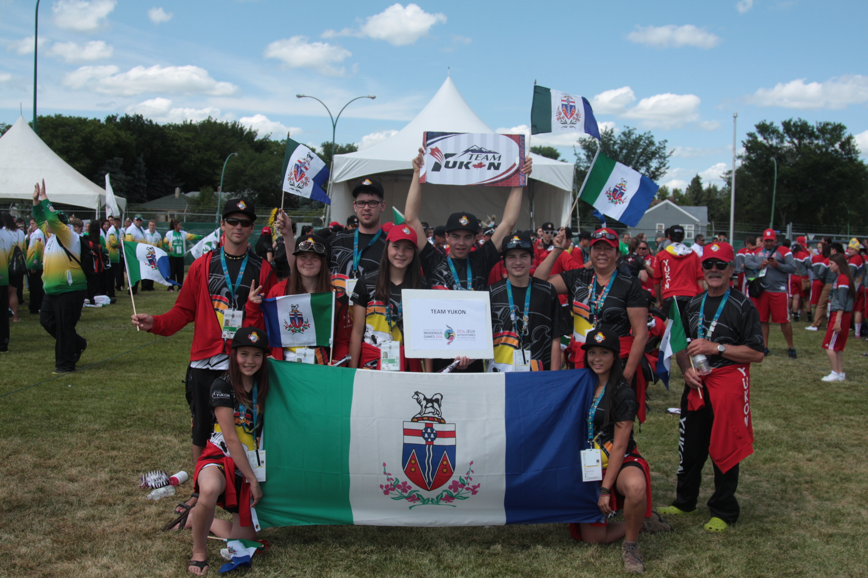
Team Yukon
Team Yukon is comprised of a committee, athletes, coaches, and interested parties. Team Yukon has participated in NAIG games since 1990 and is very proud of their accomplishments. The sport and cultural events have offered life changing introductions, challenges, and triumphs for our youth to star, compete and succeed. Current members of Team Yukon look forward to ensuring that the legacy of Team Yukon continues.

Team Yukon 2023

Team Yukon will consist of a contingent of around 150 athletes, coaches, mission staff, and chaperones. The only reason why Team Yukon will not compete in a offered sport, is if we cannot find a coach or enough athletes to field a team.
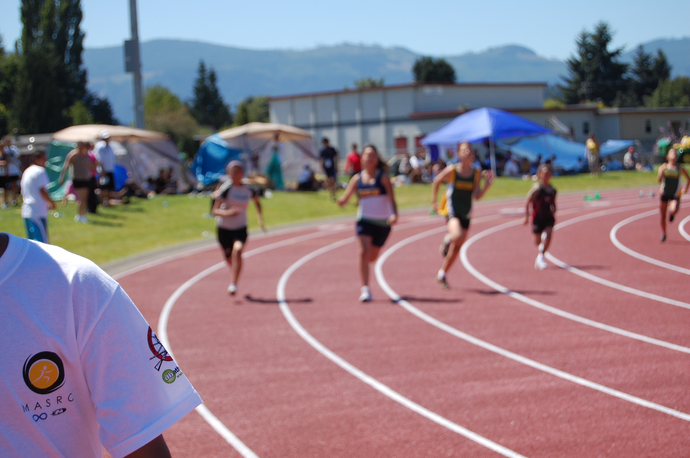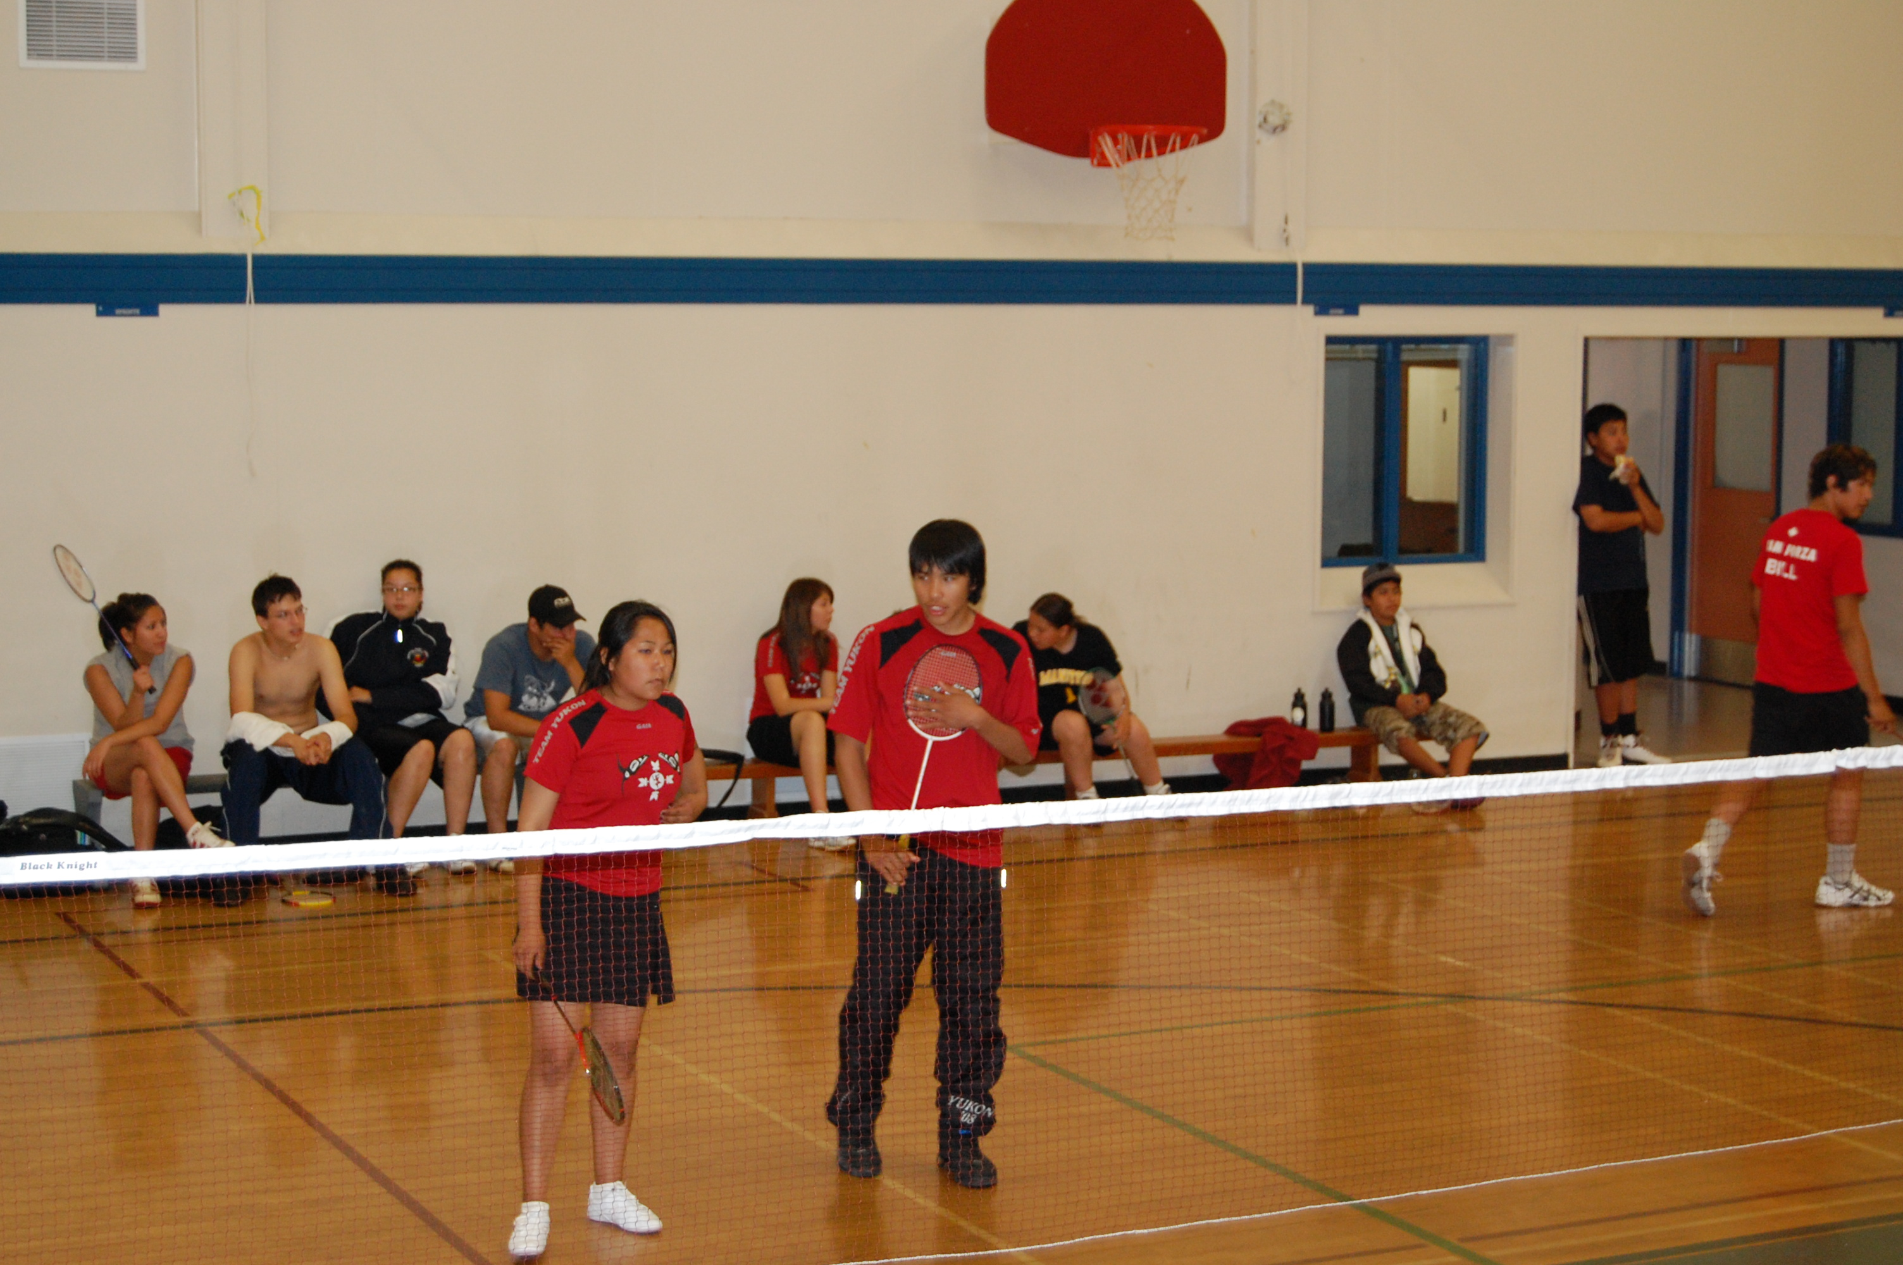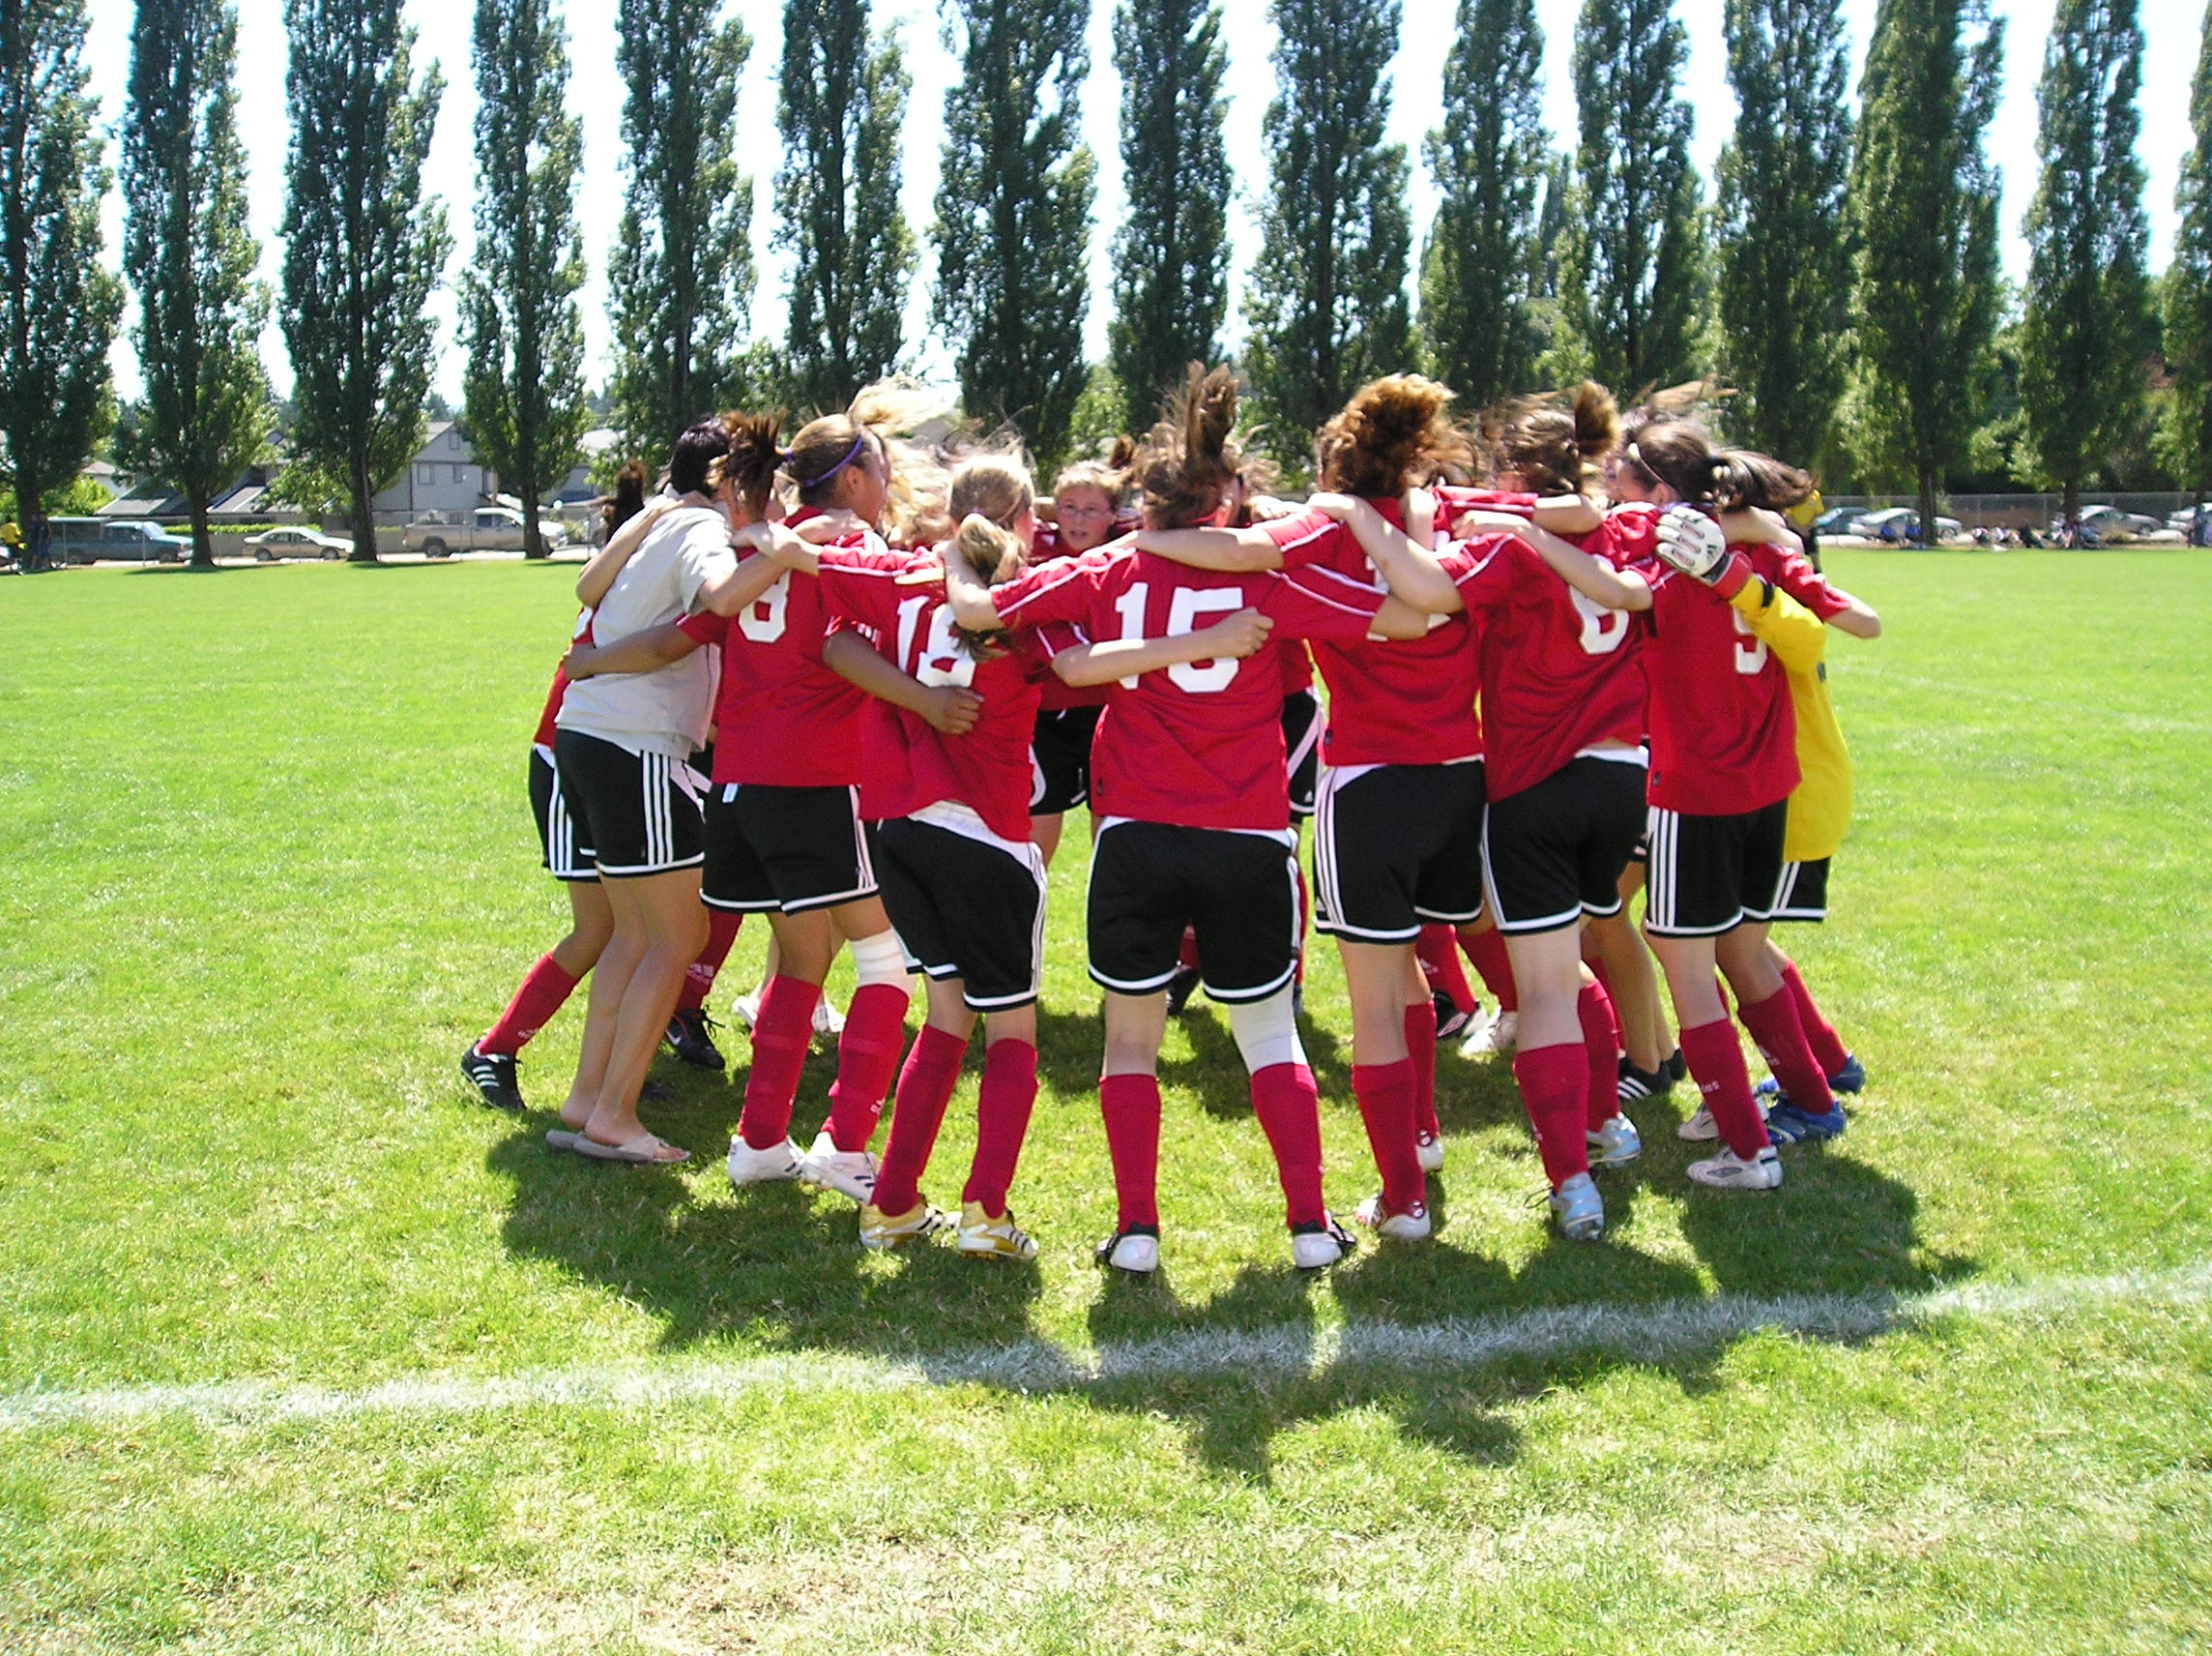
Team Yukon 2023 athletes will compete in the following:

- Archery,
- Athletics,
- Badminton,
- Basketball,
- Canoe and kayak,
- Rifle shooting,
- Soccer,
- Softball,
- Swimming,
- Volleyball,
- Wrestling

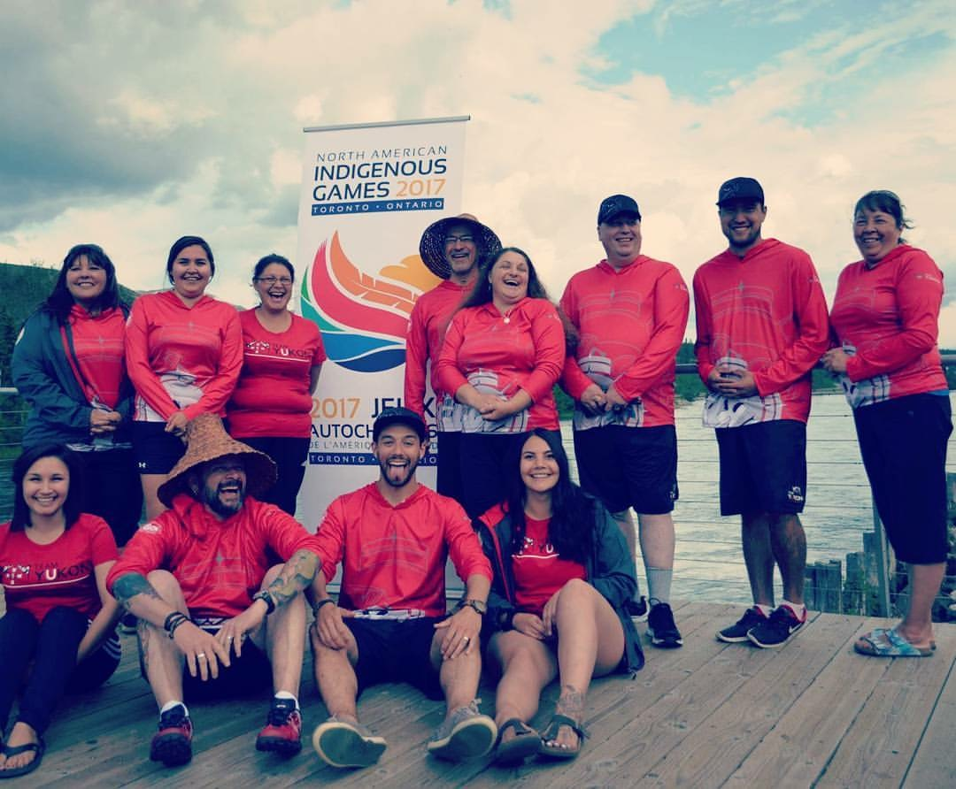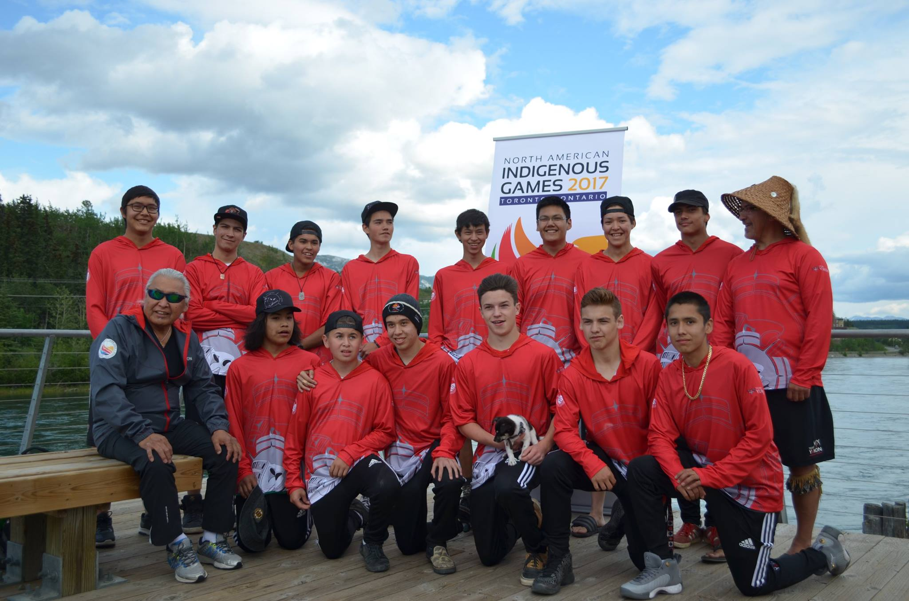

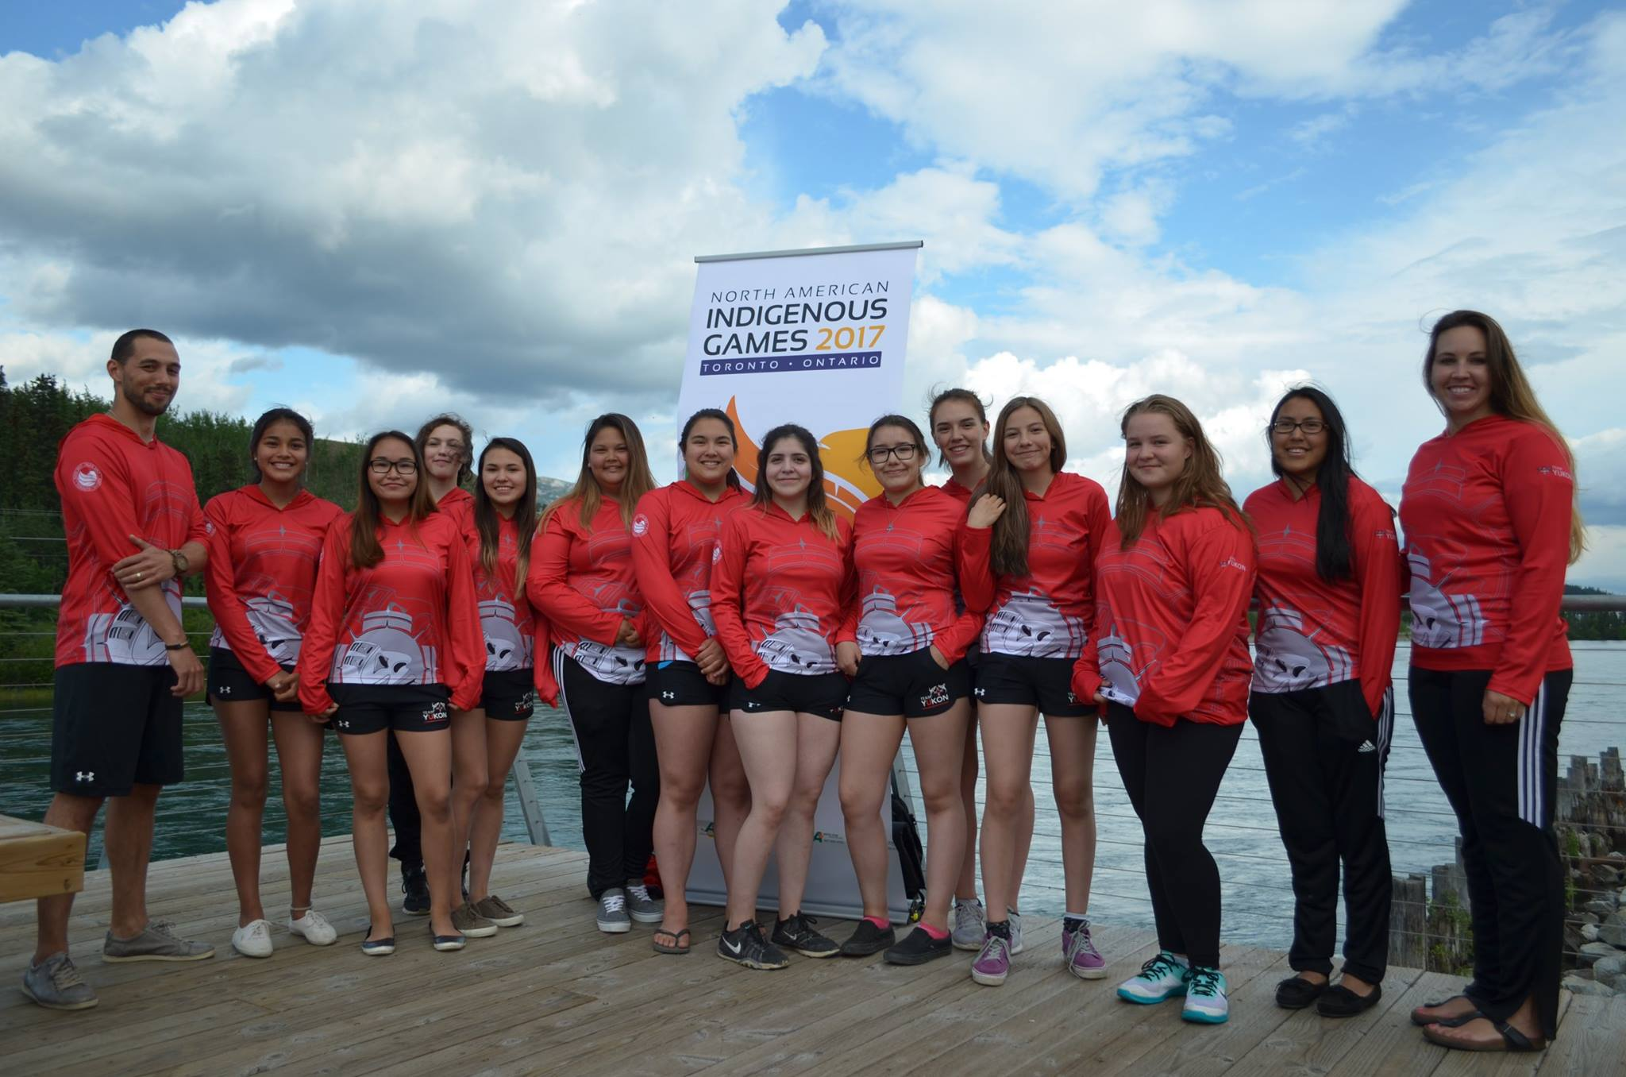

Team Yukon Contacts

Gael Marchand  Chef de Mission  ed@yasc.ca  (867) 334-7696 | Megan Cromarty  Assistant Chef de Mission  megan.cromarty@yukon.ca  (867) 333-9626 | Karee Vallevand  Assistant Chef de Mission  kevallevand@hotmail.com  (867) 334-6548

Yukon Aboriginal Sport Circle

The Yukon Aboriginal Sport Circle is a non-profit society comprised of a group of dedicated volunteers, committed to raising the participation and skill level in sport for aboriginal athletes throughout the Yukon. The YASC is in charge of organizing and financially supporting Team Yukon for NAIG. In addition, YASC is committed to encouraging and supporting Elders participation in sport and wellness thereby promoting the uniqueness of Yukon First Nation’s culture and traditions.

For more information or questions please contact:

Melissa Winters
Yukon Aboriginal Sport Circle
(867) 668-2840
melissa@yasc.ca

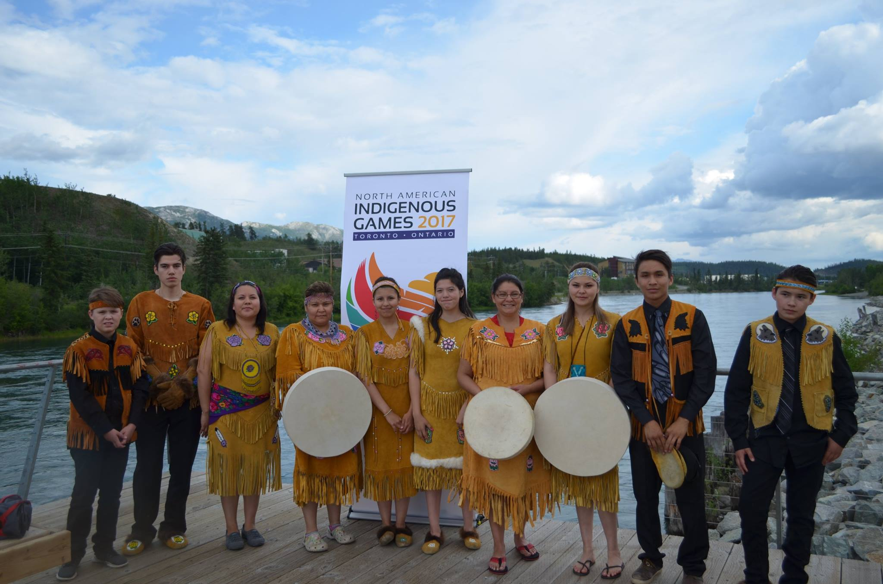

Sponsorship Packages

4 Levels of Participation (any combination of cash or in-kind):
Gold
$5,000 +

Tier 1

Tier 2
Silver

$1000 - $4,999

Bronze

$250-$999

Tier 3

FRIENDS OF TEAM YUKON
$25 - $249

Tier 4
SPONSORSHIP BENEFITS

Tier | GOLD  $5000+ | SILVER  $1000 - $4999 | BRONZE  $250 - $999 | FRIENDS OF TEAM YUKON
Logo placed on one piece of uniform * | Large logo | Medium Logo | Small Logo | -
Special NAIG Sponsor pins (with logo) for Team Yukon 2023 NAIG collection ** | Yes | - | - | -
Thank you Newspaper Ads  1 pre and 1 post Games | Large Name and Logo | Medium Name and Logo | Name | Name
Souvenir Program Ad | ½ page | ¼ page | 1/8 page | -
Recognition on inside of back cover (Souvenir Program) | Name and Logo | Name and Logo | Name | Name
Recognition on Local Radio / Television interviews | Name and Logo | Name | - | -
Sponsor Recognition Certificate | Yes | Yes | Yes | -
Invitation to Team Send Off | Yes | Yes | Yes | Yes
Invitation to the post Games appreciation night | Yes | Yes | Yes | Yes
Framed Team Photograph | Yes | Yes | - | -
YASC Website | Name, Logo and Link | Name, Logo and Link | Name | -
YASC Facebook | Name, Logo and Link | Name, Logo and Link | Name | Name
Team Yukon & YASC pieces of clothing offered | 10 | 4 | 2 | -

* Sponsorship Form must be returned no later than March 31 2023 to take advantage of this item.
** Sponsorship Form must be returned no later than May 1 2023to take advantage of this item.

Sponsorship Form

Company Name:

Contact Person:

Company Address:

Contact Phone Number: ________________ Cell: _____________

Fax number: ______________ E-mail: ______________________

Company Website: ____________________________________

Sponsorship Level

Gold ($5000 +)  Silver ($1000 - $4999) 

Bronze ($250 - $999)  Friends of Team Yukon 

Sponsorship Amount Cash $ __________________________

In Kind Value and item _______________________________

Would You Like to be Invoice for your Sponsorship Amount: 

Thank you for investing in Yukon First Nation Athletes!

Please e-mail melissa@yasc.ca

